Chapter 2 Motion in a gravitational field
Chapter Test Answers Total marks 48
Question 1
- The diagram below shows the path travelled by a soccer ball kicked from rest on the ground. On the diagram below, draw the vectors to represent the vertical, horizontal and resultant velocity at points A and B. The initial vectors are shown for reference. (5 marks)

Description | Marks
1 mark for each arrow in the correct direction | 4
Magnitude of arrows as follows:  - horizontal vector at A and B same size as initial v_{h}  - vertical vector at B shorter than initial v_{v}  - resultant vector at B shorter than initial v_{r}. | 1

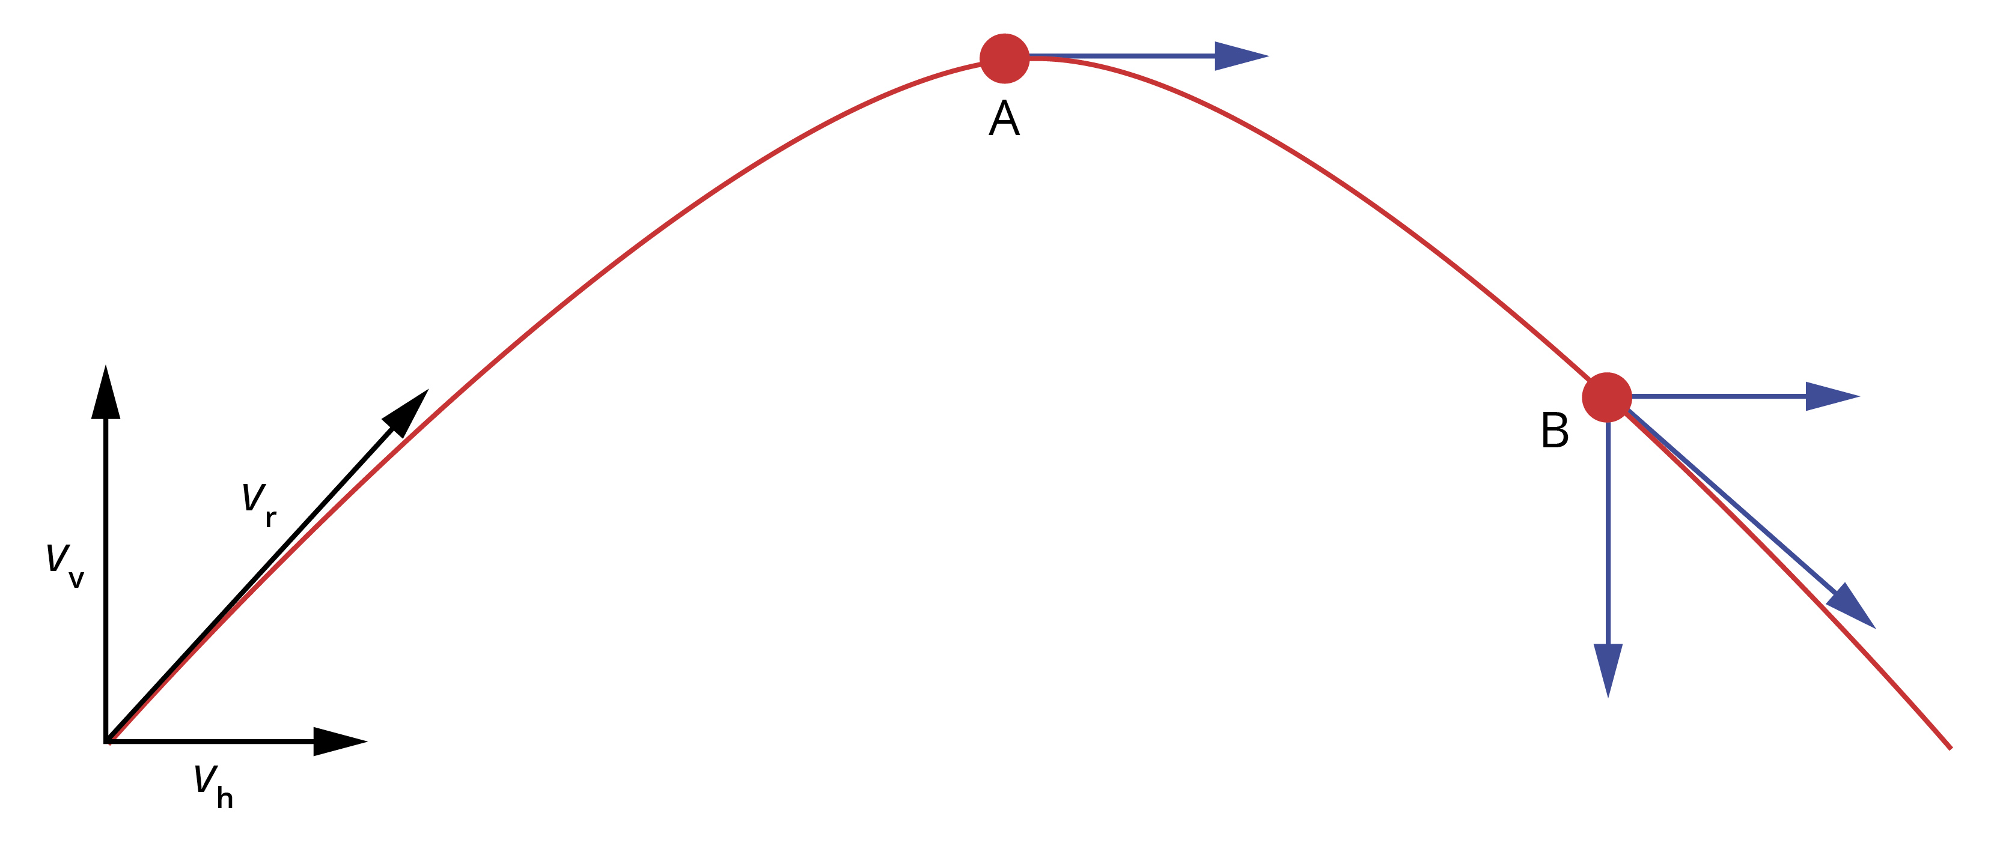

- The diagram below shows the path travelled by a shot-put, from A to D, after it has been thrown by a competitor from a height of 1.92 m.

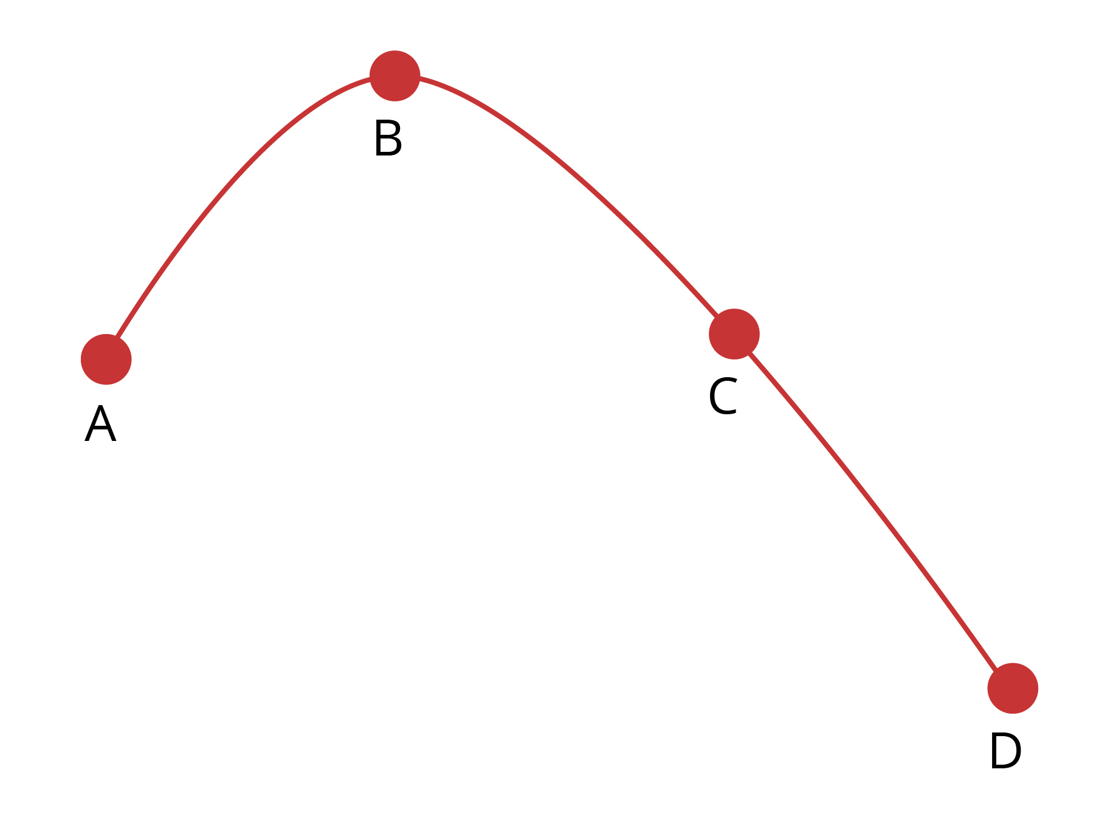

Description | Marks
Straight line decreasing with time | 1
A and C being opposite signs but equal magnitude | 1
B zero | 1
D opposite sign to A and greater magnitude | 1

On the axes below, sketch the vertical component of velocity against time as it travels from the competitor’s hand until it strikes the ground. On your graph mark the points A, B, C and D that correspond to these points on the curve. Other labels can be used to assist if needed. (4 marks)
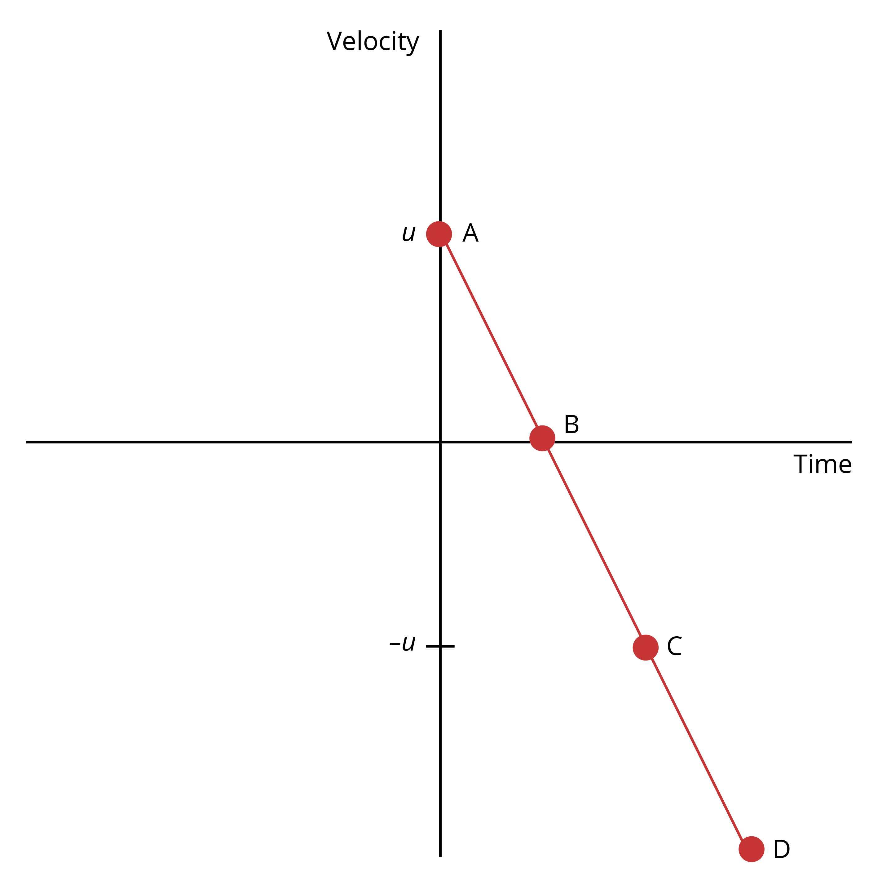

Question 2
At the Australia Day fireworks in Perth, a firework rocket is launched at an angle of 85° to the horizontal.
- At what initial velocity at the stated angle does the rocket need to be fired to reach a maximum height of 750 m if it starts from the ground? (4 marks)

Description |  | Marks
Vertical component of velocity:  v² = u² + 2as  0 = u² + 2 × −9.8 × 750  u² = 1.47 × 10⁴  u = 1.21 × 10² m s^{–1} |  | 1  1
Component of velocity at 85°: |  | 1  1
Thus,

- The firework technician needs to set the timer for the explosion so that it will explode at the maximum height. For how long must set the timer be set? (2 marks)

Description |  | Marks
v_{v} = u + at |  | 2
Thus,

Question 3
The radius of a curved section of road is 35 m. At what angle should the road be banked to allow drivers to safely take the curve at the speed limit of 80 km h⁻¹ without needing to rely on the friction between the road and tyres?
Draw a labelled diagram to show the forces involved. (5 marks)

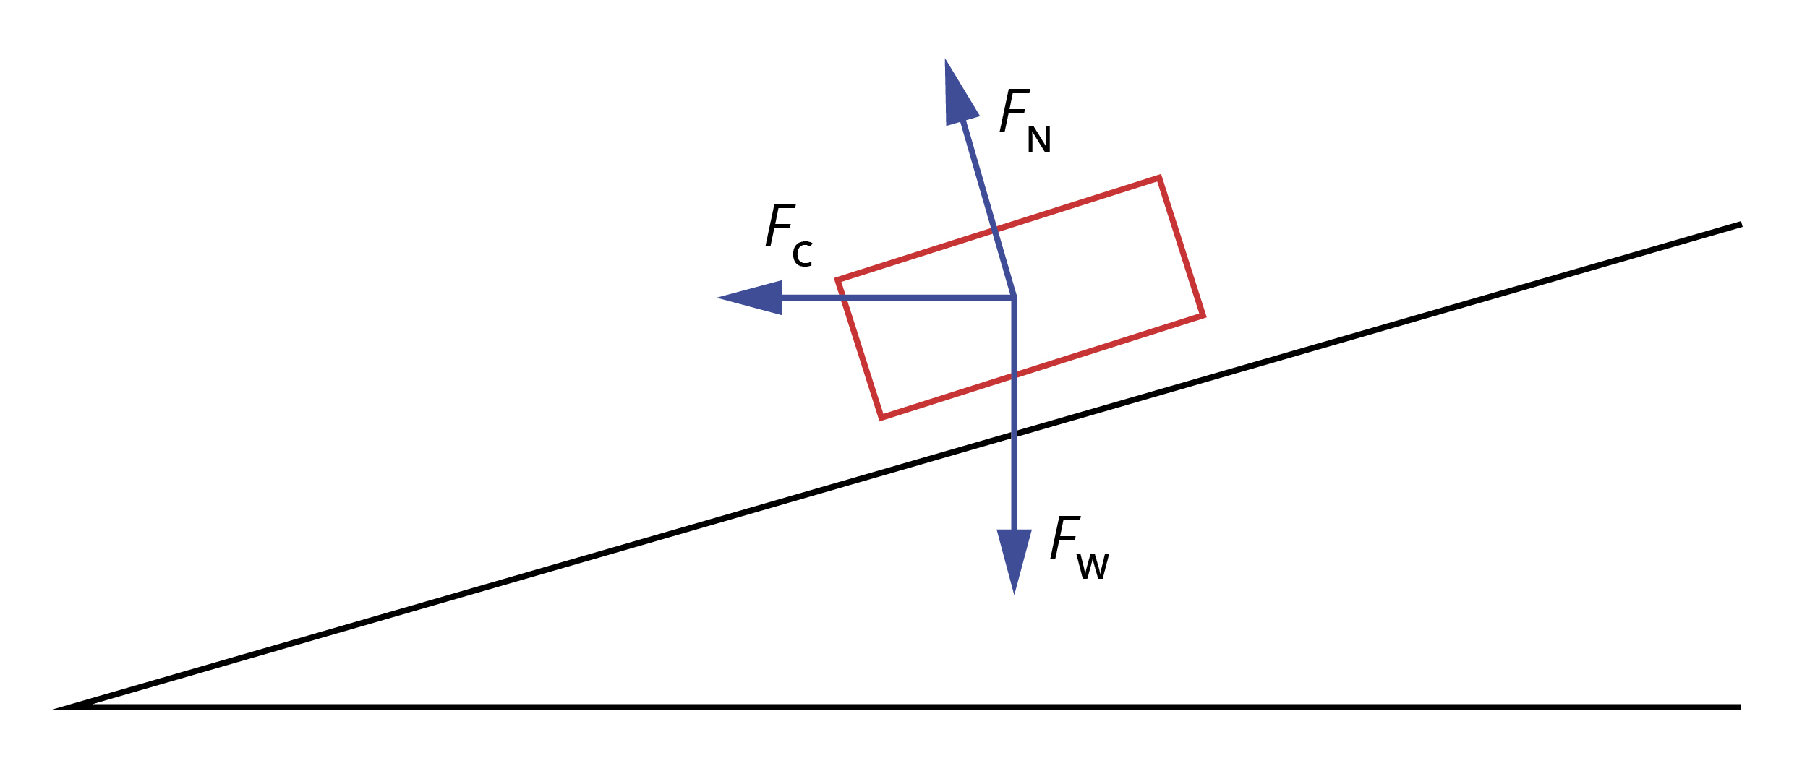

Description | Marks
Diagram | 1
v = 80 km h⁻¹ = 22.2 m s^{–1} | 1
 | 1
 | 1
Thus, θ = 55.2° | 1

Question 4
The figure below shows a section of a roller-coaster ride.
On the diagram, label the following.
- The position where a rider’s apparent weight will be greater than their actual weight as A. Explain why their apparent weight is greater at the position you have labelled.
(3 marks)
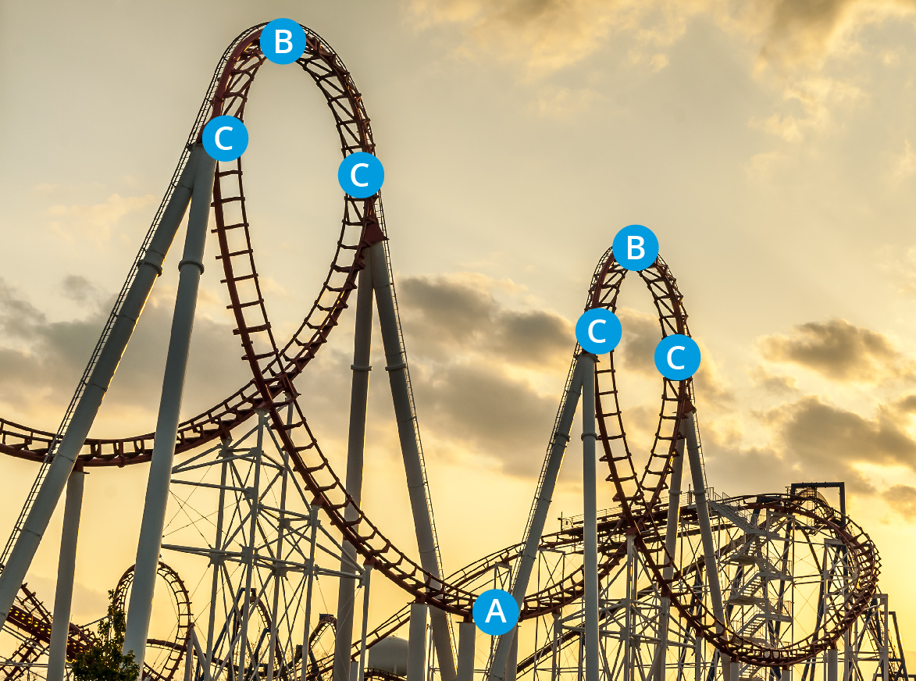

Source: Bastos/Fotolia.com

Description | Marks
Bottom of the curve labelled A | 1
At the bottom, the centripetal force is directly up (towards the centre of the circle).  The normal force from the seat which is pushing on the rider is the sum of the centripetal force and the reaction to the weight force. Both the centripetal force and the reaction to the weight force are acting upwards so the magnitude of the normal force is greater than the weight force. | 1  1

- The position where a rider’s apparent weight will be less than their actual weight as B. Explain why their apparent weight is less at the position you have labelled. (3 marks)

Description | Marks
Any one of the points labelled B | 1
At the top the centripetal force is directly down (towards the centre of the circle).  The normal force from the seat which is pushing on the rider is the sum of the centripetal force and the reaction to the weight force. The centripetal force and the reaction to the weight force are acting in opposite directions so the magnitude of the normal force is less than the weight force. | 1  1

- The position where a rider’s apparent weight will be the same as their actual weight as C. Explain why their apparent and actual weights are the same at the position you have labelled. (3 marks)

Description | Marks
Any one of the points labelled C | 1
At C the centripetal force is horizontal (towards the centre of the circle) so there is no vertical component of the centripetal force.  Thus the normal force from the seat, which is pushing on the rider, is equal to the weight force. | 1  1

Question 5
- Satellites (natural and artificial) do not require propulsion from a rocket or any other source to maintain their orbit. What is the force acting on a satellite to keep it in motion? (1 mark)

Description | Marks
The gravitational force from the body they are orbiting | 1

- Although artificial satellites require no propulsion to maintain their orbit, they are often equipped with a tank of propellant to make small corrections in their direction. Explain why, when a correction to their path is needed, the propellant will be ejected in the opposite direction to which the satellite needs to be corrected. (2 marks)

Description | Marks
This is an application of Newton’s third law of motion: for every action there is an equal and opposite reaction. The ejecting of propellant in the opposite direction to which the satellite needs to move will cause it to move in the required direction. | 2

- If a satellite was placed in orbit around the Earth at an altitude of less than approximately 150 km, it would not remain in orbit even if its initial velocity was that required to give stable orbit at 150 km. Explain why this is so. (2 marks)

Description | Marks
The atmosphere at this level would slow the satellite due to friction and so it would spiral into the Earth’s surface. | 2

- A global positioning system satellite is to be placed at an orbit around the Earth with radius 21 800 km. At what velocity should the satellite be moving in its orbit?
(5 marks)

Description | Marks
Calculation of period of orbit: | 1  2
Velocity: | 1  1

Question 6
- Astronomers investigating a newly observed planet and its moon determine the period of the moon to be 78.6 days and its radius of orbit to be 5.86 × 10⁸ km. Calculate an estimate for the mass of the planet’s moon. (4 marks)

Description | Marks
Kepler’s third law: | 1
T = 78.6 × 24 × 3600 = 7.691 × 10⁶ s | 1
Rearranged: | 1  1

- Determine the velocity with which the moon orbits the planet. (2 marks)

Description | Marks
 | 1
 | 1

- Determine the mass of the planet. (3 marks)

Description | Marks
 | 1
Thus, | 2

